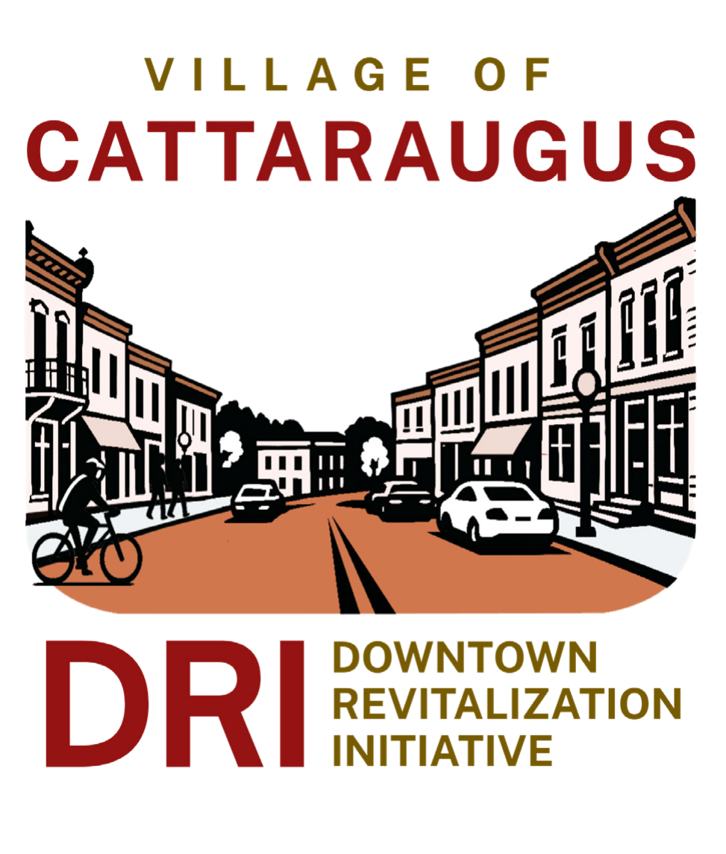
Village of Cattaraugus
Downtown Revitalization Initiative

Local Planning Committee Meeting #1 Summary
May 29, 2025 @ 5:30 – 7:30 pm | Cattaraugus-Little Valley High School Cafeteria
25 N Franklin St, Cattaraugus, NY 14719

Attendees
State Partners  ☒Ben Bidell, NYS Department of State  ☐Frank Puglisi, Governor’s Executive Office  ☒Mo Sumbundu, Governor’s Executive Office  ☒Erin Corraro, Empire State Development  ☒Tirzah Peters, Homes and Community Renewal  Village Staff  ☒Tami Stollard-Mormile  Consultant Team  ☒WSP  ☒Highland Planning  ☐Prospect Hill | Local Planning Committee  ☒Co-chair Hon. Anthony Nagel, Mayor  ☒Co-chair Paul Brown, WNY Regional Economic Development Council  ☒ Crystal Abers  ☒Lauren Bronneberg  ☐Tom Cullen  ☒Kiana Deiter  ☒Michael Jones  ☒Cedric Manganiello  ☒Rob Miller  ☒Elizabeth O’Neill  ☒Tara Perkins  ☒Mary Pritchard  ☒Nancy Radwanski  ☒Tyler Soderlund  ☒TJ Stein  ☒Justin York

Meeting Summary

Welcome and Introductions
- Ben Bidell (DOS) called the meeting to order, congratulating the Village on its DRI award and thanking the Local Planning Committee (LPC) for their commitment on behalf of New York State.
- LPC Co-Chair Mayor Anthony Nagel gave opening remarks, highlighting the village’s enthusiasm for the award and thanking those who were instrumental in the DRI application process that could not attend the first LPC meeting.
- LPC Co-Chair Paul Brown gave remarks on behalf of the WNY REDC (Western New York Regional Economic Development Council), commending the village’s dedication to successfully winning the DRI award.
- Mo Sumbundu (ESD) congratulated the village on behalf of Governor Hochul and the State DRI team, highlighting the continued excitement the village has shown throughout the DRI process.
- The consultant team introduced themselves, followed by each member of the LPC.

DRI Program Overview
- Ben presented an overview of the DRI program, clarifying the roles and responsibilities of the State agency team, the consultant team, and the LPC.

Project Goals and Timeline
- Ben reviewed the overall DRI program goals, which focus on reinvigorating regional economies by revitalizing downtowns.
- Ben then presented the timeline for the DRI program. The LPC’s responsibility falls within the planning stage, which runs from May to December 2025. The implementation phase will begin in 2026.
- Ben showcased a selection of successful DRI projects in WNY.

DRI Planning Process and Schedule
- Stephanie Camay (WSP) presented a breakdown of the 9-month long DRI planning process. The LPC will begin the process by refining the community’s future vision, then will identify opportunities and challenges in the community, then will develop and evaluate potential projects, and then will finally recommend projects to NYS for funding consideration.
- Stephanie then presented the eligible DRI project types. Eligible projects include public improvement projects, new development and/or rehabilitation of existing downtown buildings, a small project grant fund, and branding and marketing.
- Stephanie presented ineligible DRI project types/activities. Ineligible projects include planning activities, operations and maintenance, pre-award costs, property acquisition, training and program expenses, existing programs, and demolition and repaving unless part of a larger project.
- Stephanie gave an overview of project match requirements. All projects have a project minimum of $75,000 total. Privately sponsored programs have a minimum match of 25% of total project cost. Public and non-profit sponsored projects have no minimum match requirements. The LPC has the discretion to increase match goals, as appropriate, later in the DRI process.
- Stephanie presented how projects are identified though the DRI application and through the Open Call for Projects.
- Stephanie gave an overview of the Open Call for Projects, which will be open to the public for 4 to 6 weeks. The Open Call for Projects provides an opportunity for community members, property owners, and business owners to submit projects for DRI funding consideration.
- Paul Brown asked a hypothetical question: What if a project sponsor is not the owner of the property for which they are applying for funding? Ben explained that the project is still eligible but would require a letter or some other form of agreement from the property owner granting permission for the work.
- Stephanie introduced how projects will be evaluated and presented an example project evaluation worksheet. The LPC will evaluate projects based on: Alignment with Local and State Goals, Catalytic Effect, Project Readiness, Eligible Project, Cost Effectiveness, and Co-Benefits as well as local evaluation criteria to be determined.
- Stephanie presented an overview of how the final slate of recommended projects will look. The target range is for the LPC to recommend $12-15 million in funding, so that $9.7 million will ultimately be awarded by the State. A higher amount of requested funds allows for a pool of extra projects to be pulled from in the event an awarded project falls through during project implementation.
- Stephanie presented the end goal of the planning process, which culminates in the submission of a strategic investment plan to the State containing the LPC’s recommended list of projects.
- Stephanie concluded with project implementation steps. All awards are provided as reimbursement grants, meaning that the project sponsor must complete all work before monies are provided. All awards are subject to State requirements, including MWBE goals, competitive procurement, etc.

Public Engagement
- Heike Jacob (Highland Planning) gave an overview of the public engagement component of the DRI program, which is led by the consultant team and is tailored to each DRI community’s needs.
- Heike presented an overview of public engagement methods that will be used throughout the DRI process, which include LPC Meetings, Public Meetings, Stakeholder Participation, Online Engagement, and Immersive Outreach Activities.
- Mayor Nagel said that LPC members can contact him to recommend community groups or stakeholders the DRI team should reach out to.

Your Role as the LPC
- Ben introduced the LPC to their role in the DRI planning process. The LPC’s ultimate role is to conduct project evaluation and recommend projects for funding.
- Ben covered the meeting topics for each of the six LPC meetings.
- One LPC member suggested the Fireman’s Club could be a potential option as a venue for future LPC meetings.
- Paul reminded the LPC that each meeting is open to the public for observation and encouraged members to advertise meeting times with their networks.

Code of Conduct Refresher
- Ben presented a breakdown of the DRI Code of Conduct, which outlines the guidelines, standards, and procedures for LPC members to follow throughout the planning process. It requires all LPC members to act and serve in the public interest. All LPC members must sign the Code of Conduct for Members of New York State Downtown Revitalization Initiative Planning Committees (“Code of Conduct”).
- Ben outlined the processes for documenting real or perceived conflicts of interest. When a potential conflict is identified, LPC members must submit a recusal form and refrain from discussion or voting on projects for which they have a conflict. The list of recusals will be updated at each LPC meeting.
- Paul read the Code of Conduct preamble, which reminds LPC members of their obligation to disclose their potential conflicts of interest. The Code of Conduct preamble will be recited at each LPC meeting by an LPC co-chair.

Village of Cattaraugus DRI Application
- Mayor Nagel presented the preliminary DRI boundary as it was included in the village’s DRI application. The LPC may choose to amend the DRI boundary to include important buildings, sites, or economic development areas. The boundary can also be amended after reviewing and considering projects submitted during the Open Call.
- The LPC contributed ideas to amend the DRI boundary, including:
  - Extending the boundary to include the entire Village.
  - Extending the southern boundary to Memorial Drive
  - Including the rail corridor on the western side of the village and excluding the single-family residential areas on the eastern side of the village.
- The DRI core team will return to the LPC with a revised version of the boundary at LPC Meeting #2.
- Mayor Nagel then summarized each potential DRI project included in the Village’s DRI application. The application included a range of public, private, and nonprofit project ideas. Projects identified in the DRI application showcase the DRI’s potential in the village. All projects included in the DRI application will still need to submit a Project Form to be considered for funding.

Visioning and Goals Exercise
- Heike presented the initial community vision for the DRI, which reads:
  - “The Village of Cattaraugus envisions a vibrant, walkable Main Street that celebrates our historic red-brick charm, natural beauty, and deep-rooted cultural heritage. By honoring our industrial rail legacy and connecting it to outdoor recreation and regional trail networks, we will create a dynamic destination for dining, lodging, and community events. This transformation will spark economic growth, support local businesses, create jobs, and inspire a new generation of residents to call Cattaraugus home.”
- Heike also presented the initial community goals, which include:
  - Attract new businesses while supporting existing businesses
  - Foster sense of community through public gathering places
  - Preserve the historic business district
  - Revitalize housing for families, seniors, and workforce
  - Increase walkability, bikeability, and accessibility of our community
  - Promote commerce through tourism
- Heike led a group discussion on the draft vision and goals.
- The LPC said that the vision and goals should address issues such as the need to leave the village for essentials such as groceries and gas the need to improve communication within the village, among other ideas.

Next Steps and Public Comment
- Ben presented preliminary dates for future LPC meetings, which are June 26, August 7, September 11, October 16, and November 13.
  - One LPC member has a conflict with the October 16 date.
- Ben gave the LPC a summary of their next steps in the process, which include:
  - Review the DRI Guidance Document
  - Review the community’s DRI application
  - Complete the DRI LPC training
  - Review, sign, and return the Code of Conduct (if needed)
- The floor was opened to members of the public to provide comments. The following comments or questions were made:
  - Would like to see the DRI boundary extended to Memorial Drive
  - Will project owners have the chance to present their projects?
    - Ben explained that there are multiple ways in which project sponsors can familiarize the LPC with their projects, which includes the potential for presentations during LPC Meeting #4.
  - The meeting was hard to hear for senior citizens.
  - The school band room was suggested as a meeting space because it has better acoustics.
  - What if a project asks for more in funding than they need? Or if their finances fall through?
    - Ben answered that it will be the job of the LPC to decide whether they feel confident in each project sponsor’s ability to reliably complete their project. Stephanie also noted that the consultant team will work with project sponsors and will be able to speak more about their capacity and reliability.
  - Could banks lend to project sponsors who do not have the financial capital to complete their projects?
    - Ben noted that this will depend on the lending institution, but bridge loans are a common method to securing funds prior to DRI reimbursement.
  - Are project sponsors still required to meet the DRI match requirements if they do their own work?
    - Ben explained that project sponsors are not allowed to self-complete their work and are required to use a competitive bid process to select contractors, per NYS requirements, but each agency that will administer the final grant awards has slightly different requirements.

